**KidsHealth.org**

The most-visited site  
devoted to children's  
health and development

**Broken Bones**

The harder kids play, the harder they fall. The fact is, broken [bones](http://kidshealth.org/en/parents/bones-muscles-joints.html), or fractures, are common in childhood and often happen when kids are playing or participating in sports.

Most fractures affect the upper extremities: the wrist, the forearm, and above the elbow. Why? When kids fall, it's a natural reflex for them to throw their hands out in an attempt to stop the fall.

Many kids will have a broken bone at some point. Most aren't too big of a deal, but fractures can be scary for kids and parents alike. Here's what to expect.

**How Do I Know if It's Broken?**

Falls are a common part of childhood, but not every fall results in a broken bone. The classic signs of a fracture are pain, swelling, and deformity (which looks like a bump or change in shape of the bone). However, if a break is non-displaced (when the pieces on either side are straight in line with one another), it may be harder to tell.

Some telltale signs that a bone is broken are:

* You or your child heard a snap or a grinding noise during the injury.
* There's swelling, bruising, or tenderness around the injured part.
* It's painful for your child to move it, touch it, or press on it; if the leg is injured, it's painful to bear weight on it.
* The injured part looks deformed. In severe breaks, the broken bone might poke through the skin.

**What Do I Do?**

If you suspect that your child has a fracture, you should seek medical care immediately.

If your child has either of the following, do not move your child and call 911 for emergency care:

* your child may have seriously injured the head, neck, or back
* the broken bone comes through the skin. Apply constant pressure with a clean gauze pad or thick cloth, and keep your child lying down until help arrives. Don't wash the wound or push in any part of the bone that's sticking out.

For less serious injuries, try to stabilize the injury as soon as it happens by taking these quick steps:

1. Remove clothing from around the injured part. Don't force a limb out of the clothing, though. You may need to cut clothing off with scissors to prevent your child from having unnecessary added pain.
2. Apply a cold compress or ice pack wrapped in cloth. Do not put ice directly on the skin.
3. Place a makeshift splint on the injured part by:
   * keeping the injured limb in the position you find it
   * placing soft padding around the injured part
   * placing something firm (like a board or rolled-up newspapers) next to the injured part, making sure it's long enough to go past the joints above and below the injury
   * keeping the splint loosely in place with first-aid tape or a wraparound bandage
4. Get medical care right away, and don't allow the child to eat, in case surgery is needed.

**Different Types of Fractures**

A doctor might be able to tell whether a bone is broken simply by looking at the injured area. But the doctor will order an X-ray to confirm the fracture and determine what type it is.

Reassure your child that, with a little patience and cooperation, getting an X-ray to look at the broken bone won't take long. Then, he or she will be well on the way to getting a cool — maybe even colorful — cast that friends can sign.

For little ones who may be scared about getting an X-ray, it can help to explain the process like this: "X-rays don't hurt. Doctors use a special machine to take a picture to look at the inside of your body. When the picture comes out, it won't look like the ones you take with your camera. Doctors know how to look at these pictures to see things like broken bones."

A fracture through the growing part of a child's bone (called the [growth plate](http://kidshealth.org/en/parents/growth-plate-injuries.html)) may not show up on an X-ray. If this type of fracture is suspected, the doctor will treat it even if the X-ray doesn't show a break.

Because their bones are softer and more likely to bend than break in half, kids are more likely to have **incomplete fractures** (fractures that go partially through the bone). Common incomplete fracture types include:

* **buckle or torus fracture:** one side of the bone bends, raising a little buckle, without breaking the other side
* **greenstick fracture:** a partial fracture in which one side of the bone is broken and the other side bends (this fracture resembles what would happen if you tried to break a stick that had just been cut from a tree)

Mature bones are more likely to break completely. A stronger force will also result in a **complete fracture** of younger bones. A complete fracture may be a:

* **closed fracture:** a fracture that doesn't break the skin
* **open (or compound) fracture:** a fracture in which the ends of the broken bone break through the skin (these have an increased risk of infection)
* **non-displaced fracture:** a fracture in which the pieces on either side of the break line up
* **displaced fracture:** a fracture in which the pieces on either side of the break are out of line (which might require the doctor to realign the bones or require surgery to make sure the bones are properly aligned before casting)

Other common fracture terms include:

* **hairline fracture:** a thin break in the bone
* **single fracture:** the bone is broken in one place
* **segmental:** the bone is broken in two or more places in the same bone
* **comminuted fracture**: the bone is broken into more than two pieces or crushed

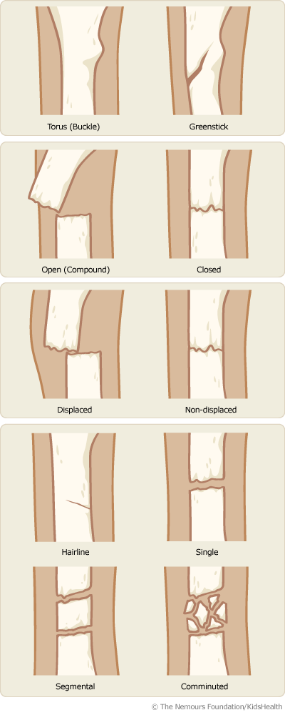

**Getting a Splint**

The doctor might decide that a **splint** is all that's needed to keep the bone from moving so it can heal. Whereas a cast encircles the entire broken area and will be removed by the doctor when the bone is healed, a splint usually supports the broken bone on one side.

When the doctor puts on a splint, a layer of cotton goes on first. Next, the splint is placed over the cotton. A splint may be made of stiff pieces of plastic or metal or can be molded out of plaster or fiberglass to fit the injured area comfortably. Then cloth or straps (which usually have Velcro) are used to keep the splint in place. The doctor might need to readjust the splint later.

**Getting a Cast**

Most broken bones will need a [**cast**](http://kidshealth.org/en/parents/cast-faq.html) to keep the bone from moving so it can heal. A cast is essentially a big bandage with two layers — a soft cotton layer that rests against the skin and a hard outer layer that prevents the broken bone from moving.

Casts for broken bones usually are made of either:

* **plaster of paris:** this heavy white powder forms a thick paste that hardens quickly when mixed with water. Plaster of paris casts are heavier than fiberglass casts and don't hold up as well in water. They are typically used when the strongest hold is needed.
* **synthetic (fiberglass) material:** these casts come in many bright colors and are lighter and cooler. The fiberglass (a kind of moldable plastic) covering is water-resistant, but the padding underneath is not. You can, however, sometimes get a waterproof liner. The doctor putting on the cast will decide whether your child should get a fiberglass cast with a waterproof lining.

Although kids might think a cast is cool when it's finally on, the process of getting one can be scary, especially for a child in pain. Knowing what happens in the cast room might help ease some worry — both yours and your child's.

For displaced fractures (in which the pieces on either side of the break are out of line), the bone will need to be set before putting on a cast. To set the bone, the doctor will put the pieces of the broken bone in the right position so they can grow back together into one bone (this is called a **closed reduction**).

A closed reduction is when the doctor realigns the broken bone so that it heals in a straighter position. Realigning the bones is a painful procedure, so sedation is given so the child won't feel it. This medicine usually is given through an intravenous (IV, into a vein) line. A cast is then put on to keep the bone in position. You can expect the doctor to take another X-ray immediately after the realignment procedure to make sure the bones are in good position.

If the fracture is complicated or more serious, an **open reduction** might be necessary. Open reduction is a surgical procedure in which an incision or cut is made in the skin and metal pins and plates are attached to the broken bone fragments to better stabilize the break while it heals. This is done under general [anesthesia](http://kidshealth.org/en/parents/anesthesia-basics.html).

**Additional Treatment**

Although most broken bones simply need a cast to heal, other more serious fractures (such as compound fractures) might require surgery to be properly aligned and to make sure the bones stay together during the healing process.

Open fractures need to be cleaned thoroughly in the sterile space of an operating room before they're set because the bone's exposure to the outside environment poses a risk of infection.

With breaks in larger bones or when the bone breaks into more than two pieces, the doctor may put a metal pin in the bone to help set it before placing a cast. When the bone has healed, the doctor will remove the pin.

For the most severe breaks, a surgical repair may require a larger metal plate to be attached to the outside surfaces of the bone, or a rod may be put within the bone to hold bone fragments in place.

**When Will a Broken Bone Heal?**

Fractures heal at different rates, depending upon the age of the child and the type of fracture. For example, young children may heal in as little as 3 weeks, while it may take 6 weeks for the same kind of fracture to heal in teens.

It's important for your child to wait to play games or sports that might use the injured part until your doctor says it's OK.

**Preventing Broken Bones**

Although fractures are a common part of childhood, some kids are more likely to have one than others. For example, those with an inherited condition known as osteogenesis imperfecta have bones that are brittle and more susceptible to breaking.

Be sure your child is getting enough calcium and vitamin D to decrease the risk of developing osteoporosis (a condition that causes bones to be more fragile and likely to break) later in life.

Also, don't forget to motivate kids to get involved in regular physical activities and exercise, which are very important to good bone health. Weight-bearing exercises such as jumping rope, jogging, and walking also can help develop and maintain strong bones.

Although it's impossible to keep kids out of harm's way all the time, you can help to prevent injuries by taking simple safety precautions, like [childproofing your home](http://kidshealth.org/en/parents/childproof.html), making sure kids always wear proper safety gear such as helmets when participating in [sports](http://kidshealth.org/en/parents/sports-safety.html), and using [car seats and seat belts](http://kidshealth.org/en/parents/auto.html) for kids at every age and stage.

If your child does get a broken bone, remember that even though it can be frightening, a fracture is a common, treatable injury. With a little patience, your child will be back to playing and running around before you know it.

Reviewed by: [Rupal Christine Gupta, MD](http://kidshealth.org/en/parents/reviewers.html#g)

Date reviewed: August 2015

Note: All information on KidsHealth® is for educational purposes only. For specific medical advice, diagnoses, and treatment, consult your doctor.

© 1995-2016 The Nemours Foundation. All rights reserved.

Images provided by The Nemours Foundation, iStock, Getty Images, Corbis, Veer, Science Photo Library, Science Source Images, Shutterstock, and Clipart.com